Lab Task 1:
The Basic HTTP GET/response interaction.
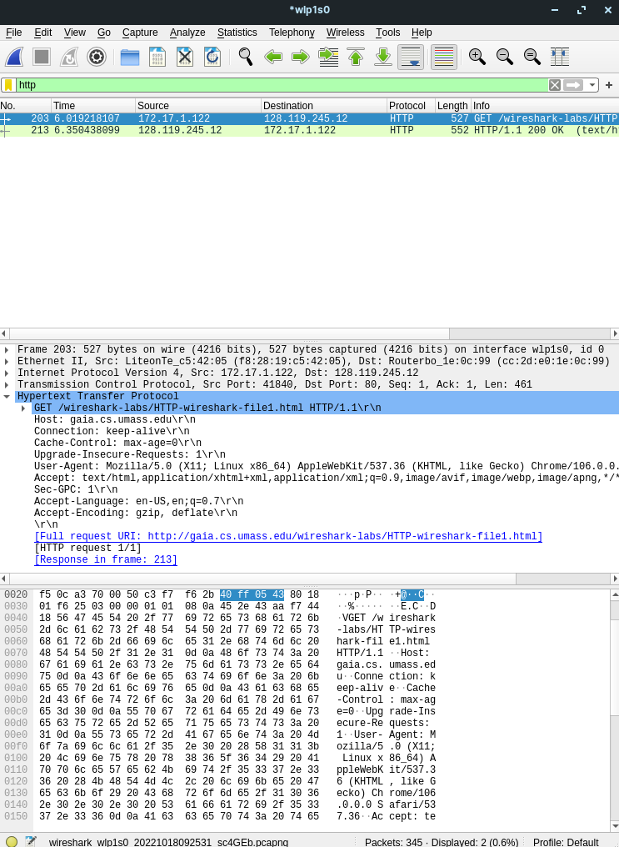
Answers:
- Browser running HTTP version 1.1.
- The server version is:
- Accept Language is: “en-US, en;1=0.7\r\n”

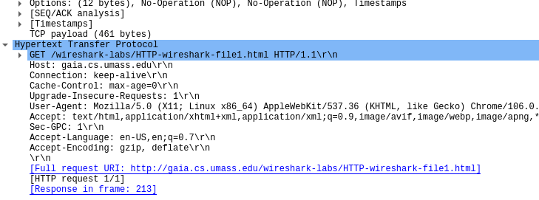

- My machine IP is: 172.17.1.122
The server’s IP address is: 127.119.245.12

- Status code is: 200
- Last modified time is:

- Bytes size is:

- No all of the headers can be found in the raw data.

Task 02:
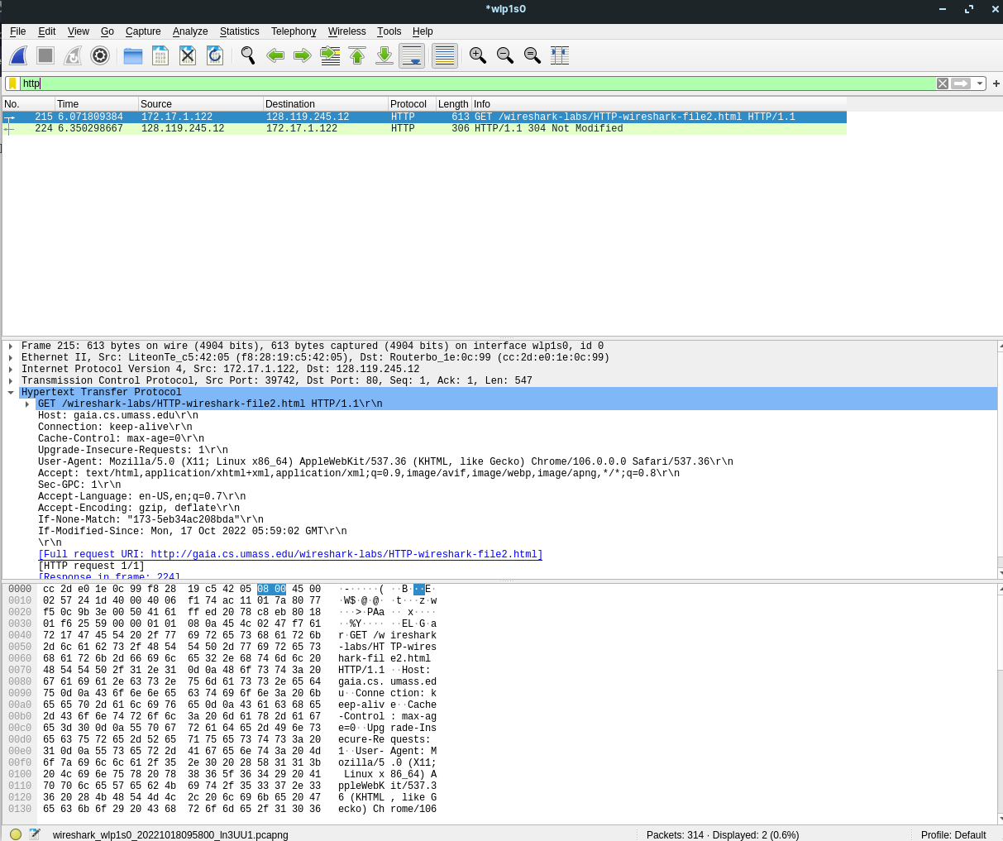

Answers:
- No, it’s not showing in 200,OK response.

- Yes, the server explicitly returns the contents of the file.

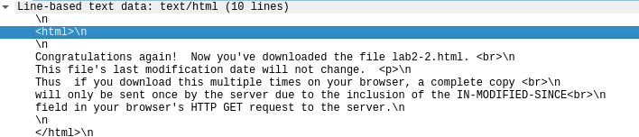

- Yess, it’s showing:

- 304 Not modified is the code and it does not explicitly returns the content of the file.

